DATE: 02.08.2019
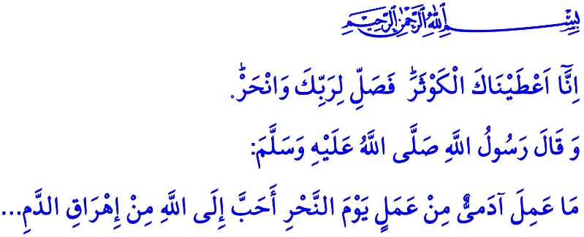
MAKE SACRIFICE FOR YOUR LORD
Honorable Muslims!
In the verse I have recited, the Almighty Allah (swt) states: “Indeed, We have granted you, o Prophet, abundant goodness. So, pray and sacrifice to your Lord alone!”
In the hadith I have read, the Prophet Muhammad (saw) states, “The son of Adam does not do any deed on the Day of Sacrifice that is dearer to Allah (swt)than sacrificing an animal for Him...”
Dear Believers!
We started to feel the excitement of the Eid al-Adha, an occasion for us to get closer to Allah (swt) and to reinforce our bonds of brotherhood with Muslims. May endless praise and thanks be to Allah (swt) for allowing us to reach these blessed days. Insha’allah, we all together will reach the eid on August 11, Sunday. We are going to refresh our submission and loyalty to Allah (swt) by means of qurban, and our affection with our brothers and sisters by means of our aids and offerings.
Dear Muslims!
Qurban means sacrificing an animal of certain qualifications in accordance with certain procedures for worship purposes. As in all worships, the primary purpose of qurban is to get closer to Allah (swt). That is to say, it is the effort to attain the approval of Allah (swt). It is the desire to attain piety (taqwa). Qurban is a demonstration of respect and sincerity by obedient servants for al-Rahman. This is referred to in the words of the Almighty Allah (swt) as follows, “Neither their meat nor blood reaches Allah. Rather, it is your piety that reaches Him.”
Dear Believers!
Qurban for Allah (swt) has been a form of worship made obligatory for all nations since the Prophet Adam (as). This is referred to in the Holy Qur’an as follows, “For every community We appointed a rite of sacrifice so that they may pronounce the Name of Allah over the sacrificial animals He has provided for them...”
Let qurban remind you of Abil and Kabil, the Prophet Adam’s sons, who were put to a test of sincerity. Abil, with his contentedness and obedience to the commandment of Allah (swt) in the best manner, passed successfully the test, and Kabil failed it, with his insincerity and jealousy. For sincerity (ikhlas) and piety (taqwa) constitute the essence of worship.
Let qurban remind you also of the Prophet Ibrahim (as) and his son Ismail, both of whom were put to a test of submission. In this challenging test, a prophet as a father and his son showed all people that they could without hesitation sacrifice all they had in the cause of Allah (swt).
Let qurban remind you of the Prophet Muhammad (saw), who performed this worship every year until his death. He himself would do the slaughtering of the animal he would sacrifice; he and his family would eat from the meat of the sacrificed animal, and he would also offer some meat to his companions, and to those people in need. Qurban also bears the marks of the Prophet Muhammad’s (saw) loyalty and prayers. On it are reflected also the marks of his morals of infaq and sharing.
Dear Muslims!
Qurban is a supreme responsibility in both material and spiritual terms. It means coming together, with our family, friends, neighbors, relatives, brothers and sisters, around the same blessing. It means doing good and spending in the cause of Allah (swt), and staying conscious of the need to share His blessings with other people. It means making happy the people primarily in our close circles, the people in need, the aggrieved, the miserable, and the lonely. It means delivering compassion and joy to the homes of people in need without any discrimination of color, language, or geography. It means stretching out a hand of benevolence to countries, of whose names we may not have heard before, and people whom we may have not met before. It means grasping the meaning of being brothers and sisters, being united, and being the ummah.
Honorable Believers!
The Presidency of Religious Affairs, in cooperation with the Türkiye Diyanet Foundation, continues to carry out its organization of qurban by proxy this year, too, just as it has been for the past years. Great was your participation for the last year’s organization. Alhamdulillah, we distributed a total number of 430.000 shares of qurban, which you entrusted to us, to 17.650.000 brothers and sisters of ours who are in need, oppressed, aggrieved, and refugees.
This year, within the framework of the organization initiated under the title of “Share Your Qurban, Get Closer to Your Brothers and Sisters”, some of the shares of qurban you entrusted to us will be slaughtered in our country, and some of them by our officials on duty abroad. We will meticulously deliver your shares entrusted to us to those people truly in need. This way, we will function as a bridge of love between the hearts of Muslims, thereby strengthening the consciousness of being ummah. We will be serving for upholding and spreading the awareness of Islamic infaq, morality, assistance, and solidarity before all humanity.
The Türkiye Diyanet Foundation will keep its system of receiving donations of shares of qurban open until the evening of the Day of Arafah. We would like to invite you, our honorable community, to this charitable activity. Let us not forget that a single share of qurban will turn back to us as thousands of prayers uttered for us. You can get detailed information from the mosque officials and offices of muftis.
I would like to take this opportunity to pray to Allah (swt) that He may allow us to reach the Eid al-Adha as healthy, tranquility, and happy. May Allah the Almighty (swt) appreciate our worship of qurban and other worships.

Kawthar, 108/1-2
Tirmidhi, Adahi, 1.
Hajj, 22/37.
Hajj, 22/34. General Directorate of Religious Services

